Clean database files by using R:

---  
title: "project1 CITS3401"  
author: "Esther Chang"  
date: '2022-04-19'  
output: html_document  
---

```{r setup, include=FALSE}  
knitr::opts_chunk$set(echo = TRUE)  
```

## R Markdown

This is an R Markdown document. Markdown is a simple formatting syntax for authoring HTML, PDF, and MS Word documents. For more details on using R Markdown see <http://rmarkdown.rstudio.com>.

When you click the **Knit** button a document will be generated that includes both content as well as the output of any embedded R code chunks within the document. You can embed an R code chunk like this:

```{r }  
setwd("~/Documents/UWA/2022/CITS3401")  
seekdata=read.csv(file="seek_australia.csv")  
head(seekdata)  
```

## Including Plots

You can also embed plots, for example:

Note that the `echo = FALSE` parameter was added to the code chunk to prevent printing of the R code that generated the plot.

```{r}  
seekdata$job_description=gsub("[^A-z0-9\\. ,]", "", seekdata$job_description)  
seekdata$company_name=gsub("[^A-z0-9\\. ,]", "", seekdata$company_name)  
seekdata$geo=gsub("[^A-z0-9\\. ,]", "", seekdata$geo)  
seekdata$job_board=gsub("[^A-z0-9\\. ,]", "", seekdata$job_board)  
seekdata$job_title=gsub("[^A-z0-9\\. ,]", "", seekdata$job_title)  
seekdata$job_type=gsub("[^A-z0-9\\. ,]", "", seekdata$job_type)  
seekdata$state=gsub("[^A-z0-9\\. ,]", "", seekdata$state)  
```

```{r}  
write.csv(seekdata,"cleaned_CITS3401project1")  
```

**ETL PROCESS:**

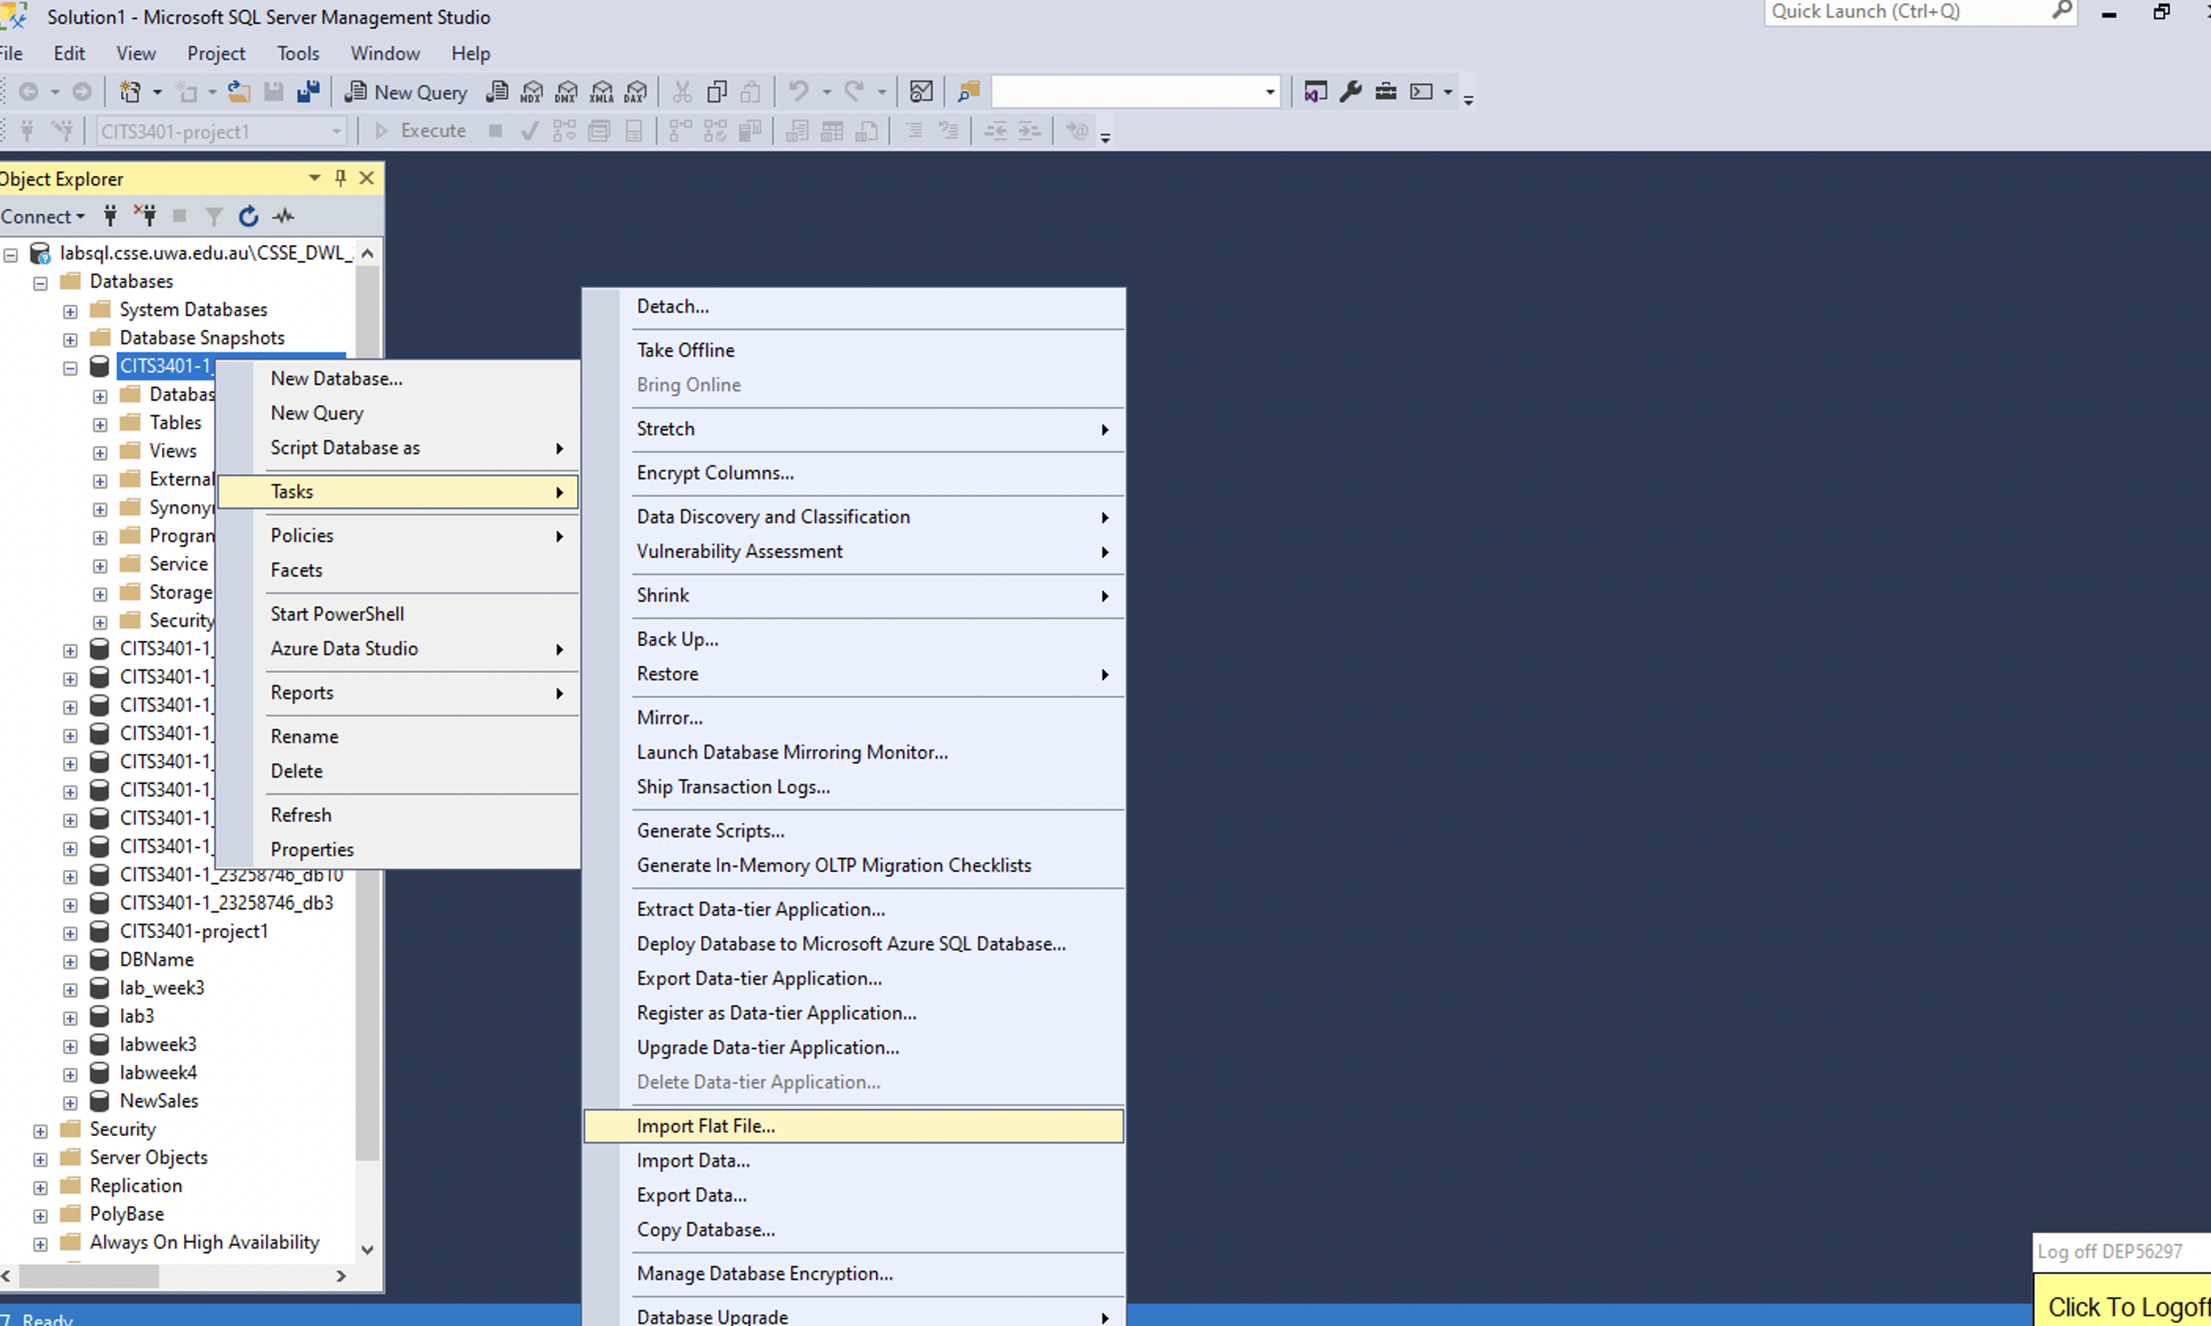

SQL SCRIPT:

update cleaned_CITS3401project1

set state = 0

WHERE state IS NULL;

GO

update cleaned_CITS3401project1

set job_description = 0

WHERE job_description IS NULL;

GO

update cleaned_CITS3401project1

set salary_offered = 0

WHERE salary_offered IS NULL;

GO

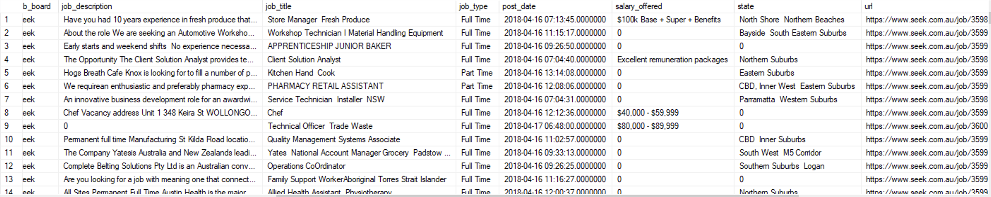

create table company_dim

(CompanyID int identity(1,1), company_name nvarchar(100) not null);

GO

Insert into [CITS3401-1_23258746_db01].[dbo].[company_dim]

SELECT distinct [company_name]

FROM [CITS3401-1_23258746_db01].[dbo].[cleaned_CITS3401project1];

GO

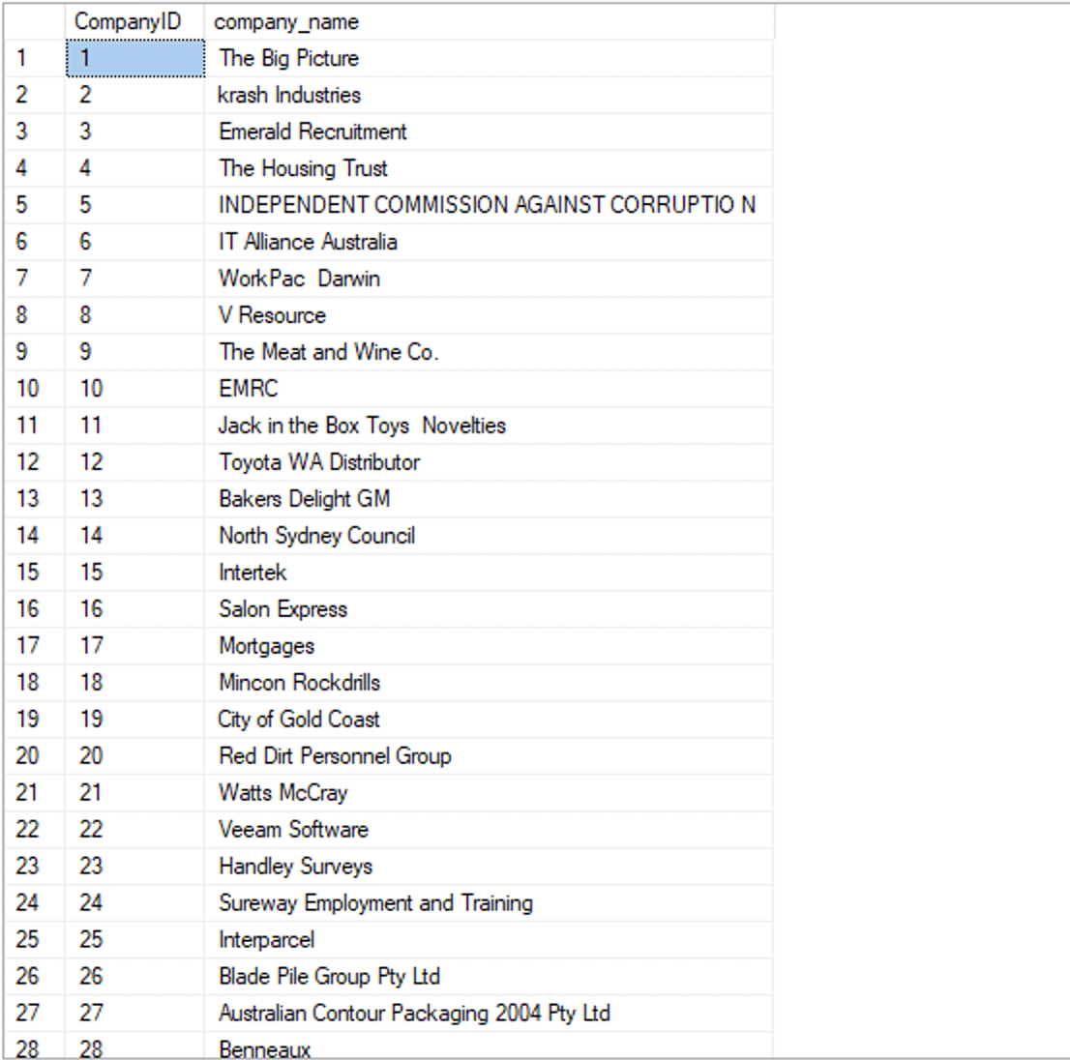

create table job_dim

(JobID int identity(1,1), category nvarchar(50) not null , job_title nvarchar(100) not null , job_type nvarchar(50) not null)

GO

Insert into [CITS3401-1_23258746_db01].[dbo].[job_dim]

SELECT distinct [category]

,[job_title]

,[job_type]

FROM [CITS3401-1_23258746_db01].[dbo].[cleaned_CITS3401project1]

GO

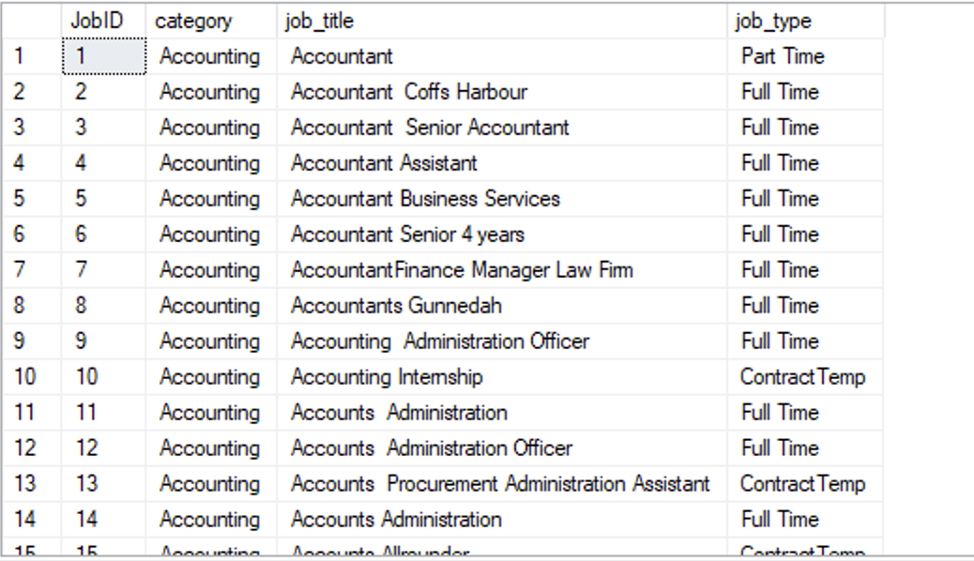

create table salary_dim

(SalaryID int identity(1,1), salary_offered nvarchar(100) null)

GO

Insert into [CITS3401-1_23258746_db01].[dbo].[salary_dim]

SELECT distinct salary_offered

FROM [CITS3401-1_23258746_db01].[dbo].[cleaned_CITS3401project1]

GO

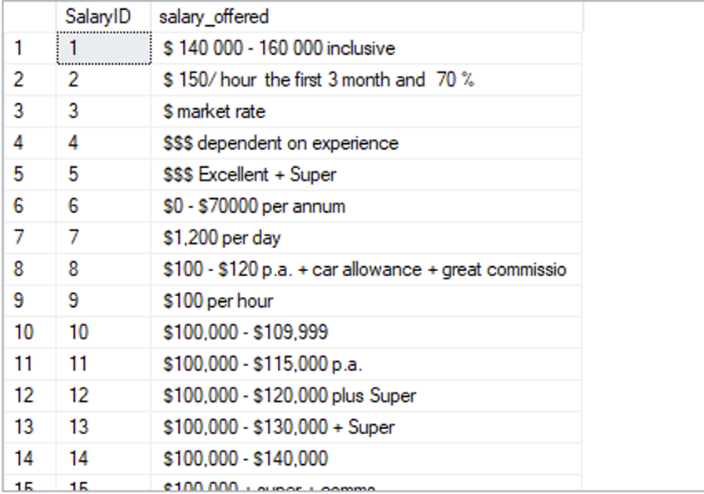

create table location_dim

(locationID int identity(1,1), geo nvarchar(50) not null , state nvarchar(50) null ,city nvarchar(50) not null )

GO

Insert into [CITS3401-1_23258746_db01].[dbo].location_dim

SELECT distinct [geo]

,[state]

,[city]

FROM [CITS3401-1_23258746_db01].[dbo].cleaned_CITS3401project1

GO

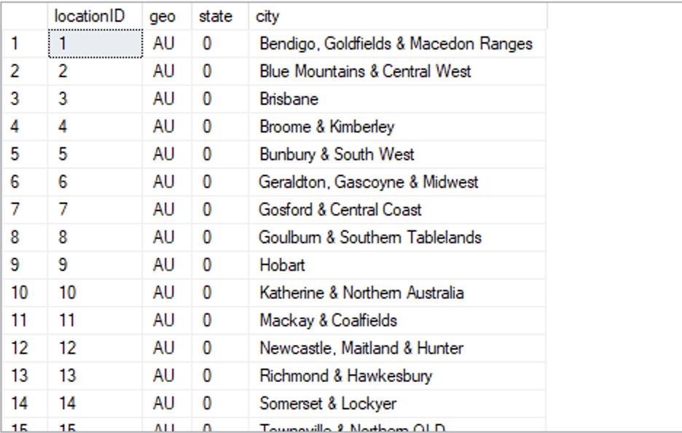

CREATE TABLE time_dim

(timeID int identity(1,1), year int not null, month int not null, day int not null);

GO

INSERT INTO dbo.time_dim (year,month,day)

(SELECT DISTINCT YEAR(post_date) AS YEAR, MONTH(post_date) AS MONTH, DAY(post_date) AS DAY From dbo.cleaned_CITS3401project1)

GO

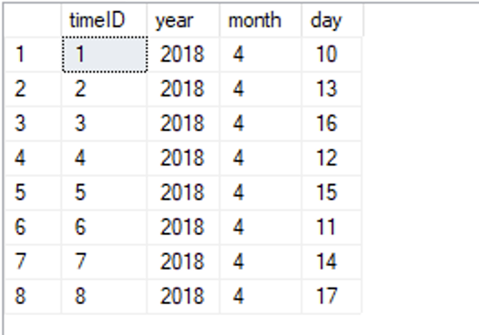

Alter table cleaned_CITS3401project1

Add LocationID int null

GO

Alter table cleaned_CITS3401project1

Add JobID int null

GO

Alter table cleaned_CITS3401project1

Add CompanyID int null

GO

Alter table cleaned_CITS3401project1

Add TimeID int null

GO

Alter table cleaned_CITS3401project1

Add SalaryID int null

GO

update cleaned_CITS3401project1

set CompanyID =t1.CompanyID

From company_dim t1 inner join cleaned_CITS3401project1 on t1.company_name = cleaned_CITS3401project1.company_name;

GO

update cleaned_CITS3401project1

set LocationID =t1.LocationID

From location_dim t1 inner join cleaned_CITS3401project1 on t1.geo = cleaned_CITS3401project1.geo and t1.city = cleaned_CITS3401project1.city

and t1.state = cleaned_CITS3401project1.state

GO

update cleaned_CITS3401project1

set JobID =t1.JobID

From job_dim t1 inner join cleaned_CITS3401project1 on t1.category = cleaned_CITS3401project1.category and

t1.job_title = cleaned_CITS3401project1.job_title

and t1.job_type = cleaned_CITS3401project1.job_type;

GO

update cleaned_CITS3401project1

set SalaryID =t1.SalaryID

From salary_dim t1 inner join cleaned_CITS3401project1 on t1.salary_offered = cleaned_CITS3401project1.salary_offered;

GO

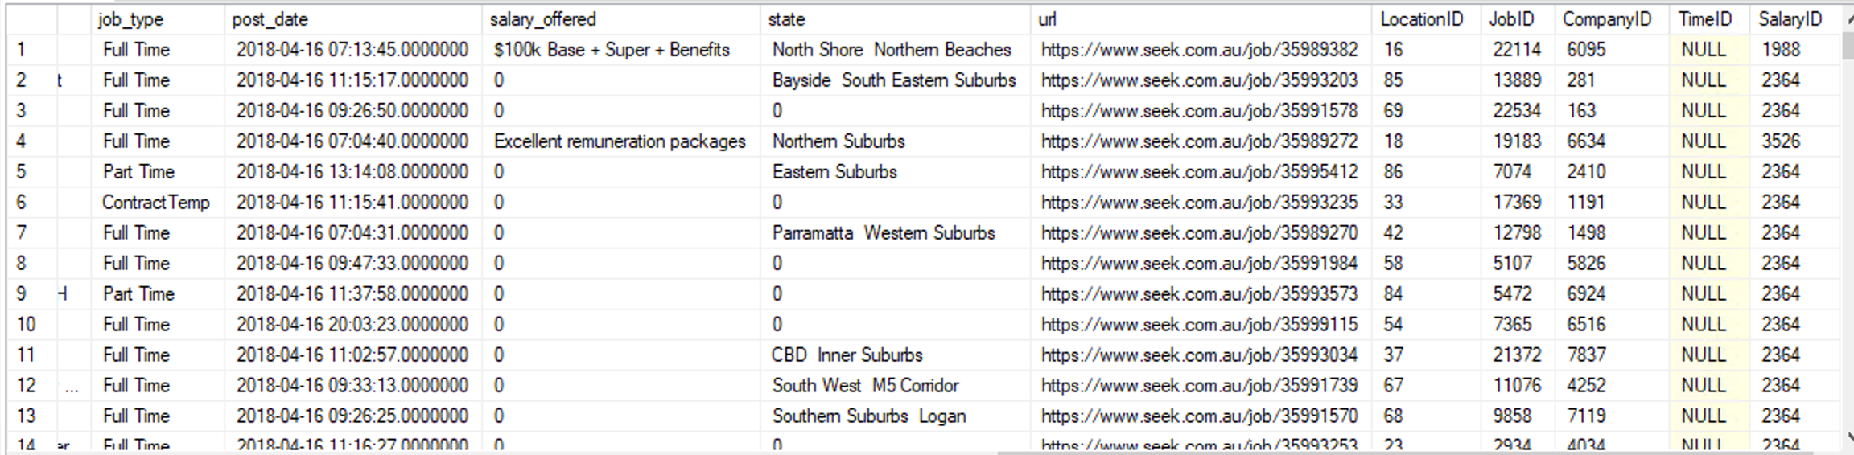

Alter table cleaned_CITS3401project1

Add YEAR int null

GO

update cleaned_CITS3401project1

set year = YEAR(post_date);

GO

Alter table cleaned_CITS3401project1

Add MONTH int null

GO

update cleaned_CITS3401project1

set MONTH = MONTH(post_date);

GO

Alter table cleaned_CITS3401project1

Add DAY int null

GO

update cleaned_CITS3401project1

set DAY = DAY(post_date);

GO

update cleaned_CITS3401project1

set timeID =t1.timeID

From time_dim t1 inner join cleaned_CITS3401project1 on t1.year = cleaned_CITS3401project1.YEAR and t1.month = cleaned_CITS3401project1.month

and t1.day = cleaned_CITS3401project1.day

GO

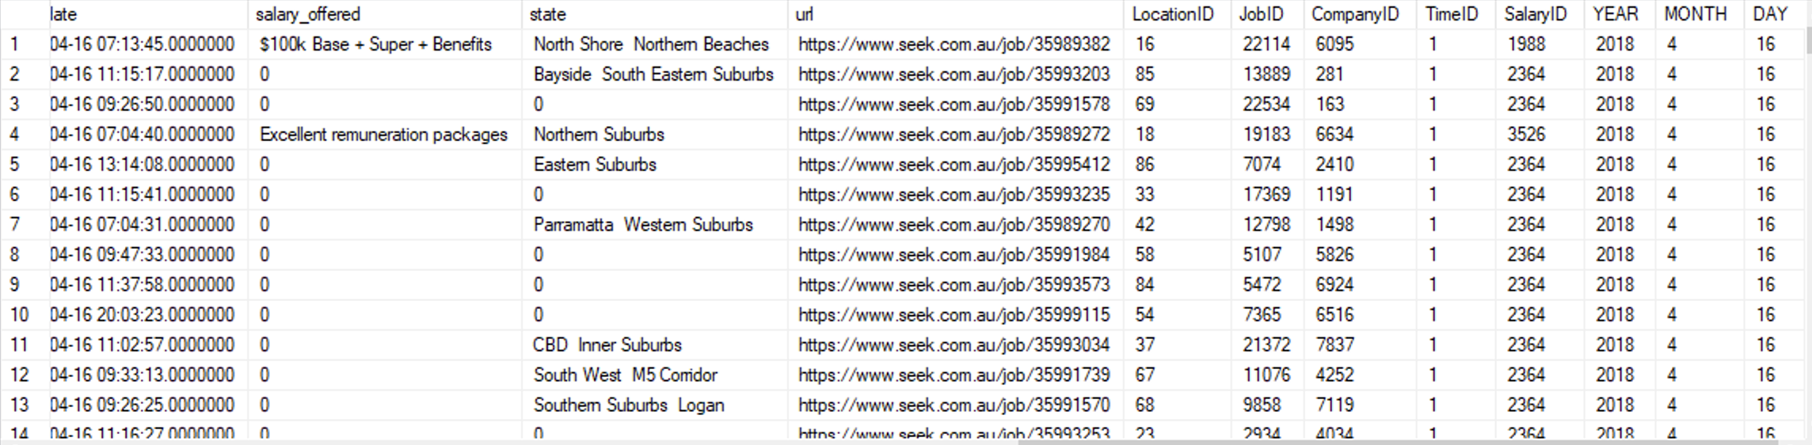

CREATE TABLE FACT_TABLE

(Count int not null, JobID int null, CompanyID int null, locationID int null, SalaryID int null, timeID int null)

GO

INSERT INTO dbo.FACT_TABLE (COUNT, LocationID, CompanyID,JobID, SalaryID, timeID)

SELECT count(*) AS COUNT

,[LocationID]

,[CompanyID],[JobID],[SalaryID],[timeID]

FROM [CITS3401-1_23258746_db01].[dbo].[cleaned_CITS3401project1]

Group by [LocationID]

,[CompanyID],[JobID],[SalaryID],[timeID]

GO

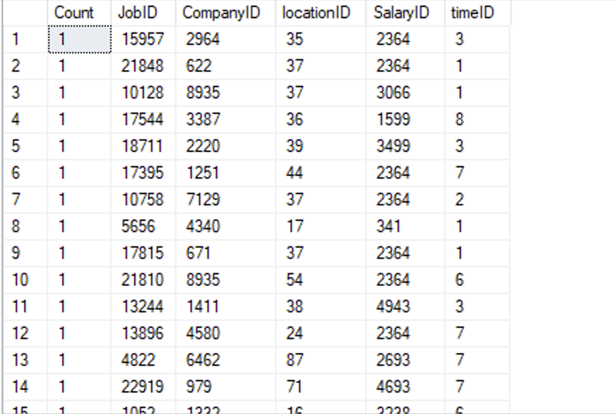

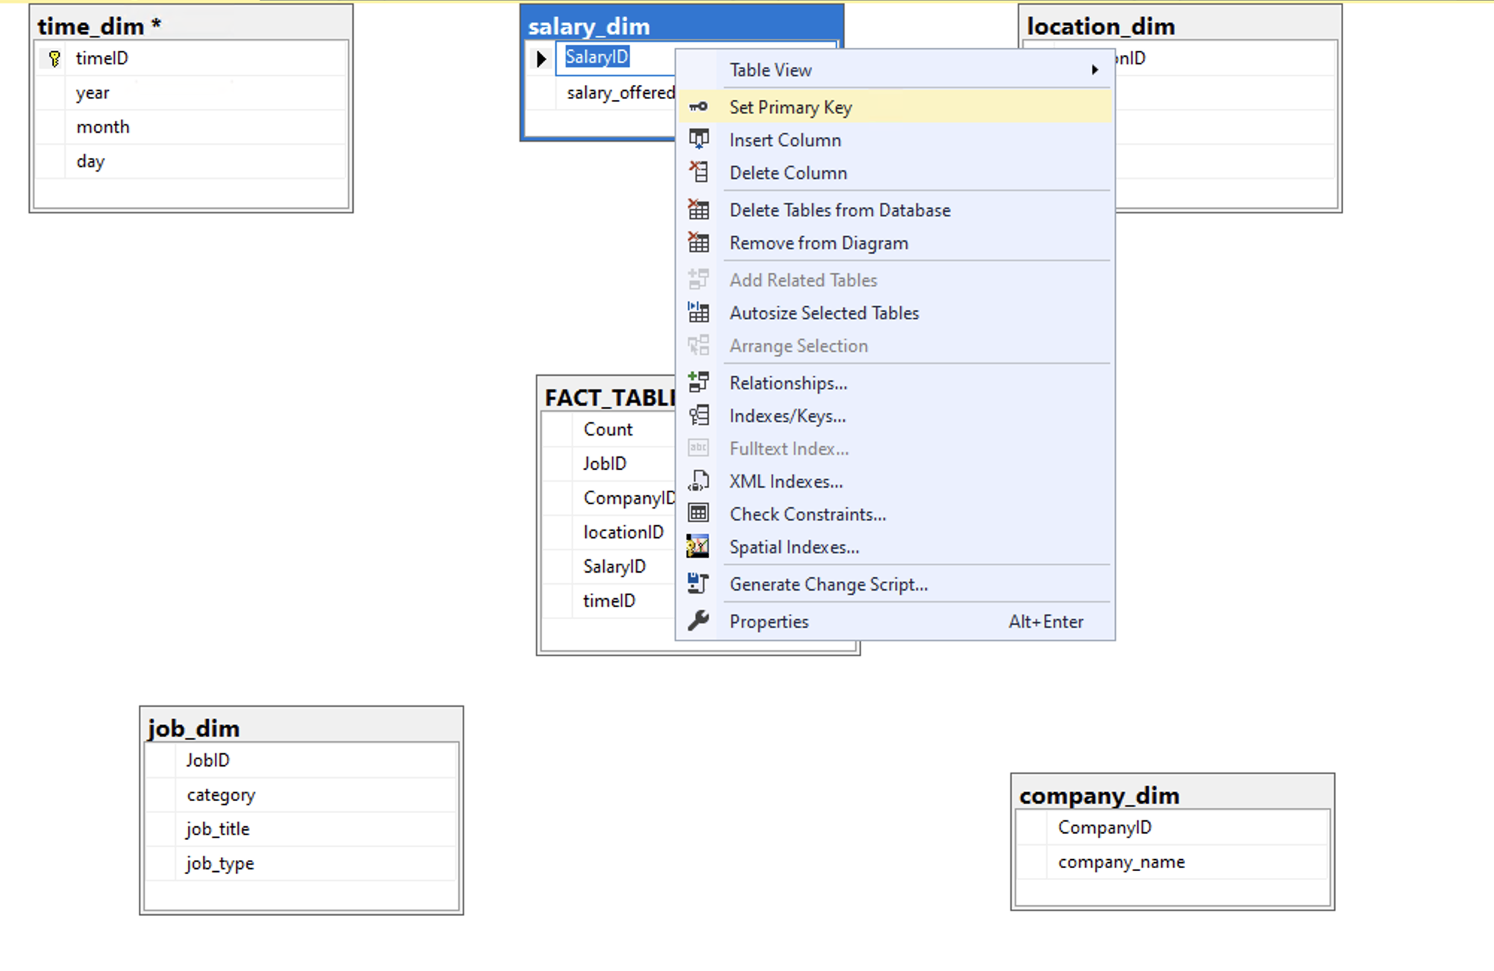

Schema of each dimension:

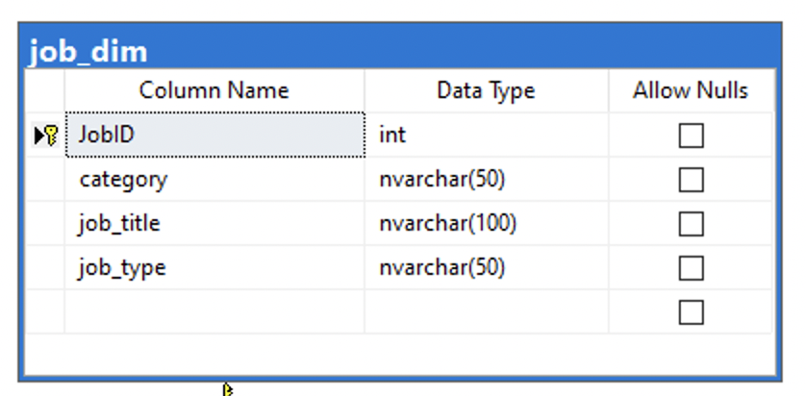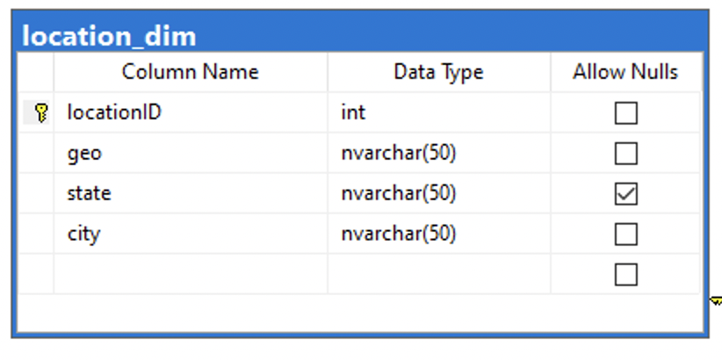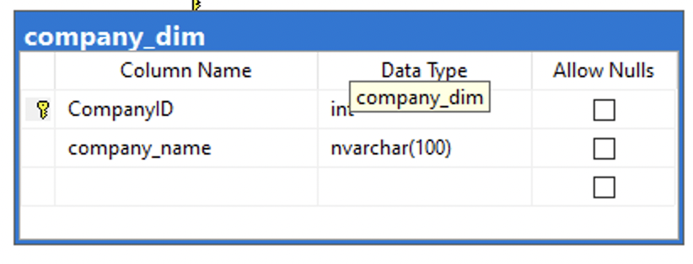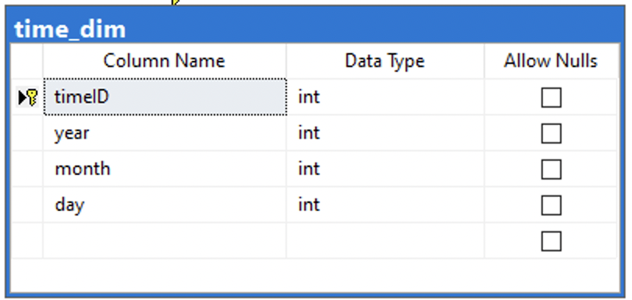

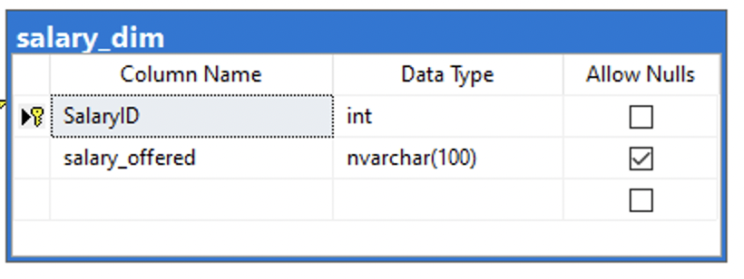

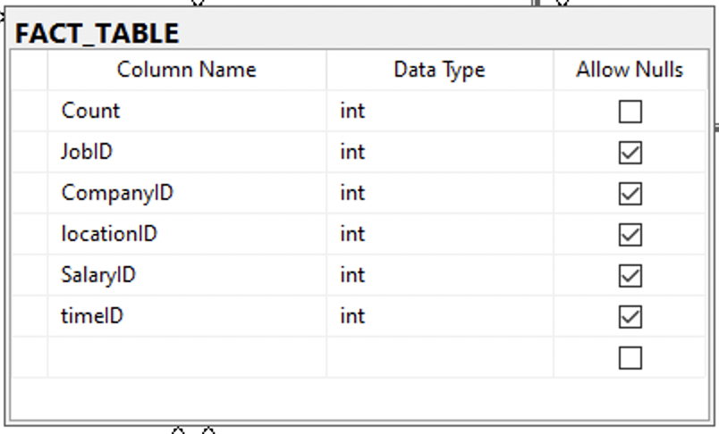

STAR SCHEMA DIAGRAM:

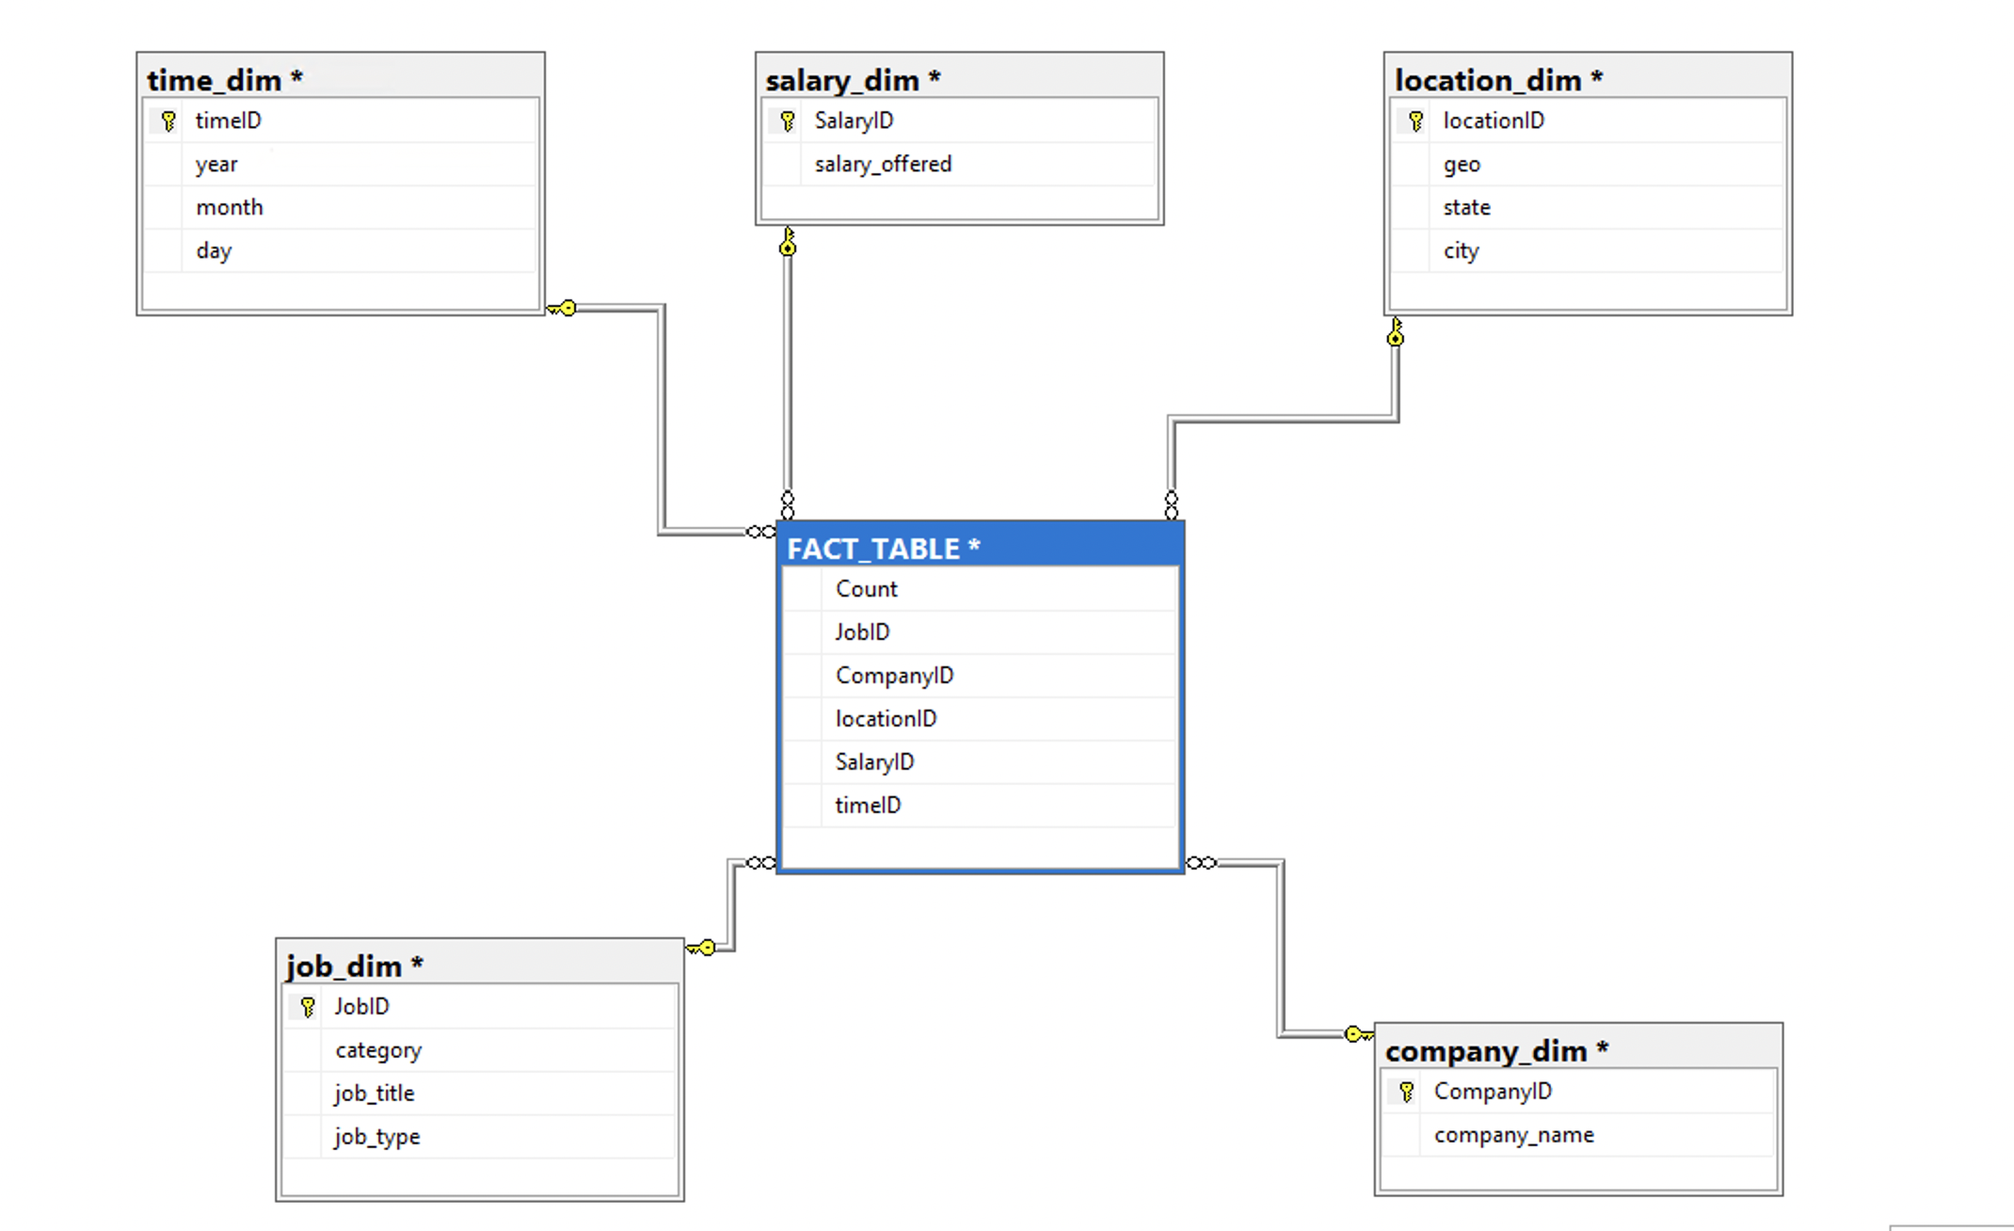

Starnet diagram

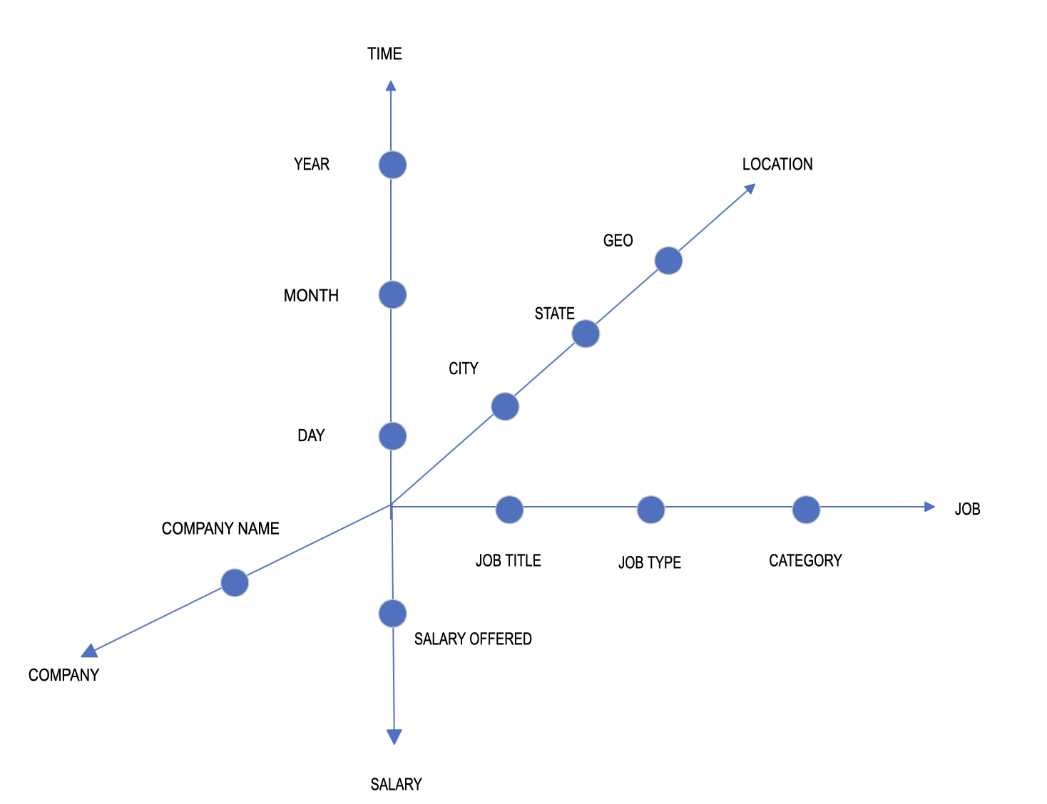

CONCEPT HIERARCHY:

TIME: Year 🡪 Month 🡪 Day

LOCATION: Geo 🡪 State 🡪 City

JOB: Category 🡪 Job type 🡪 Job title

COMPANY: Not part of a hierarchy

SALARY: Not part of a hierarchy

**Business queries:**

1. What job category is high in demand in Australia in 2018?

What companies are looking for a specific job category in Australia in 2018?

How much is the salary offered by the company for this category in 2018?

In each city, which job category is high in demand?

1. In a month, what is the number of job demands in each city of Australia?

In each state, what job category is highly requested?

1. What is the total number of job types required in 2018 in Australia?

What job type is highly requested by each state?

1. In a month, which state has the highest number of request for a specific job type?
2. What job is highly requested by companies in Australia 2018?

Footprint for business query 1:



* What job category is high in demand in Australia in 2018?
* What companies are looking for a specific job category in Australia in 2018?
* How much is the salary offered by the company for this category in 2018?
* In each city, which job category is high in demand?

Footprint for business query 2:



* In a month, what is the number of job demands in each city of Australia?
* In each state, what job category is highly requested?

Footprint for business query 3: 

* What is the total number of job types required in 2018 in Australia?
* What job type is highly requested by each state?

Footprint for business query 4:

* In a month, which state has the highest number of request for a specific job type?

Footprint for business query 5:

* What job title is highly requested by companies in Australia 2018?

**Multi-dimensional Analysis Service Solution:**

**Answering Business Queries using Analysis Solution**

Business Queries

1. What job category is high in demand in Australia in 2018?

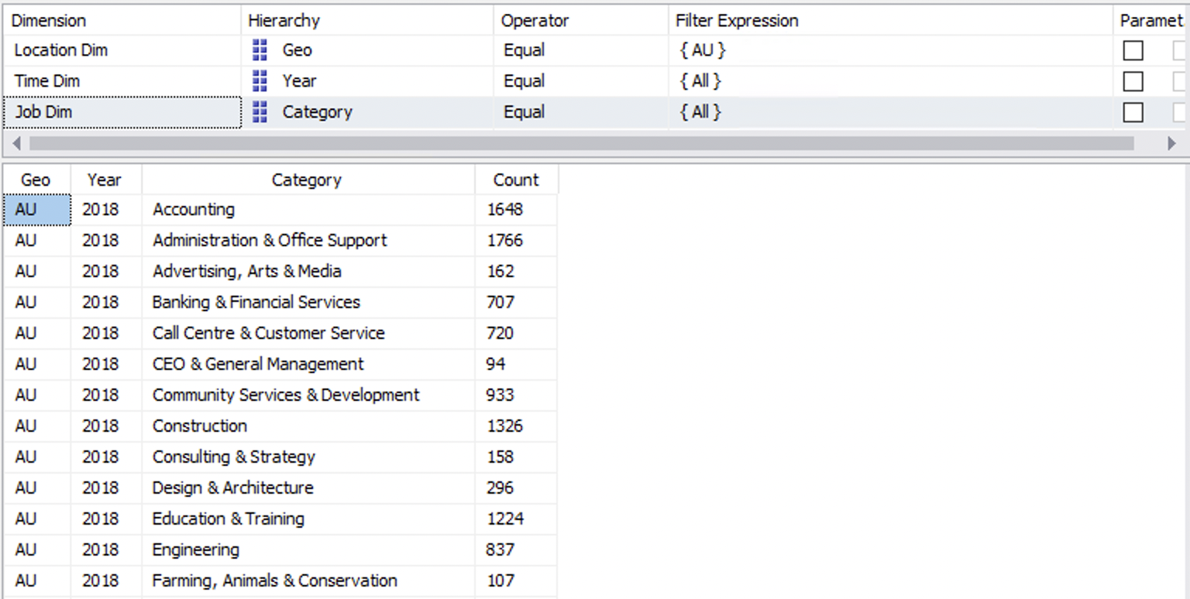

What companies are looking for a specific job category in Australia in 2018 and how many times have they appeared on seek.com.au? For example Accounting

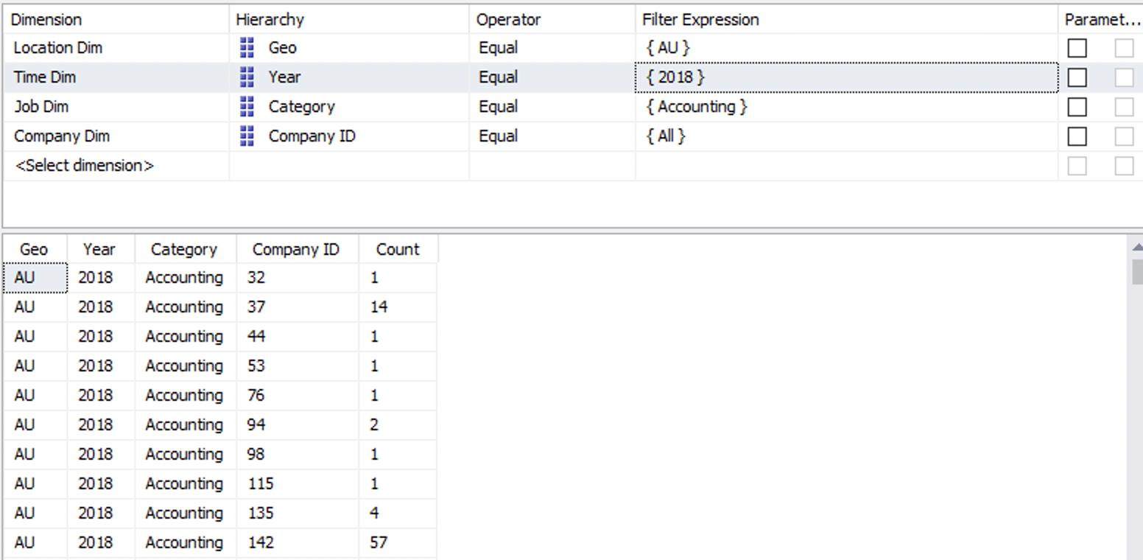

How much is the salary offered by the company for this category in 2018? For example company with ID 37.

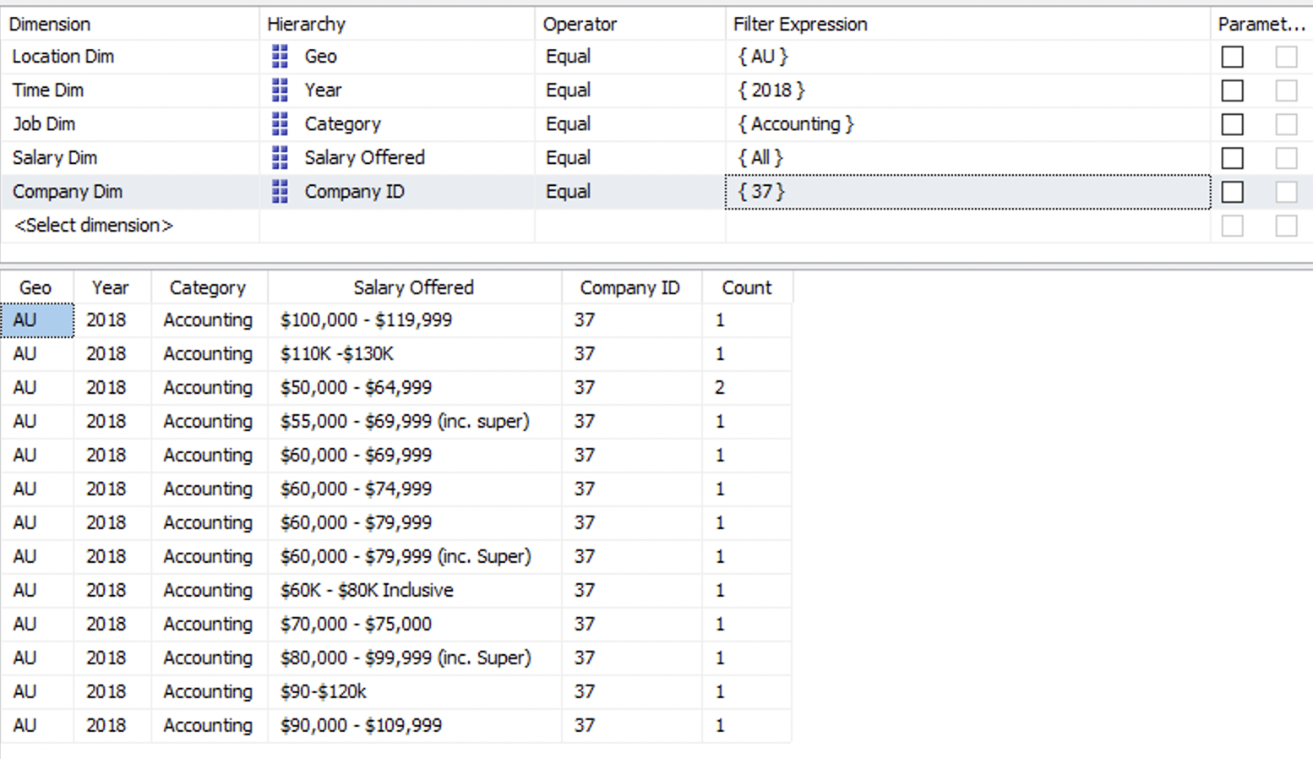

In each city, which job category is high in demand?

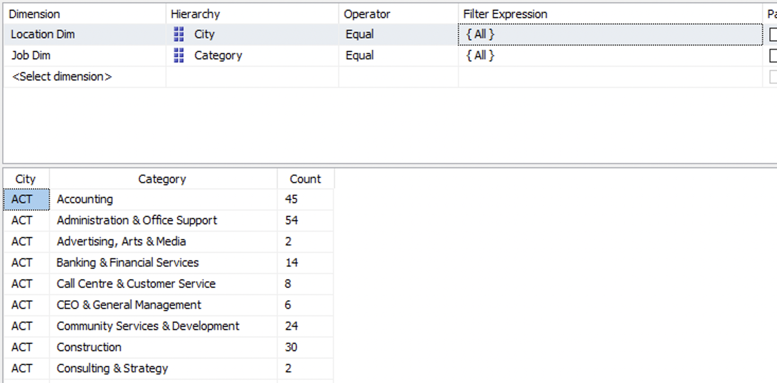

1. In a month, what is the number of job demands in each city of Australia?

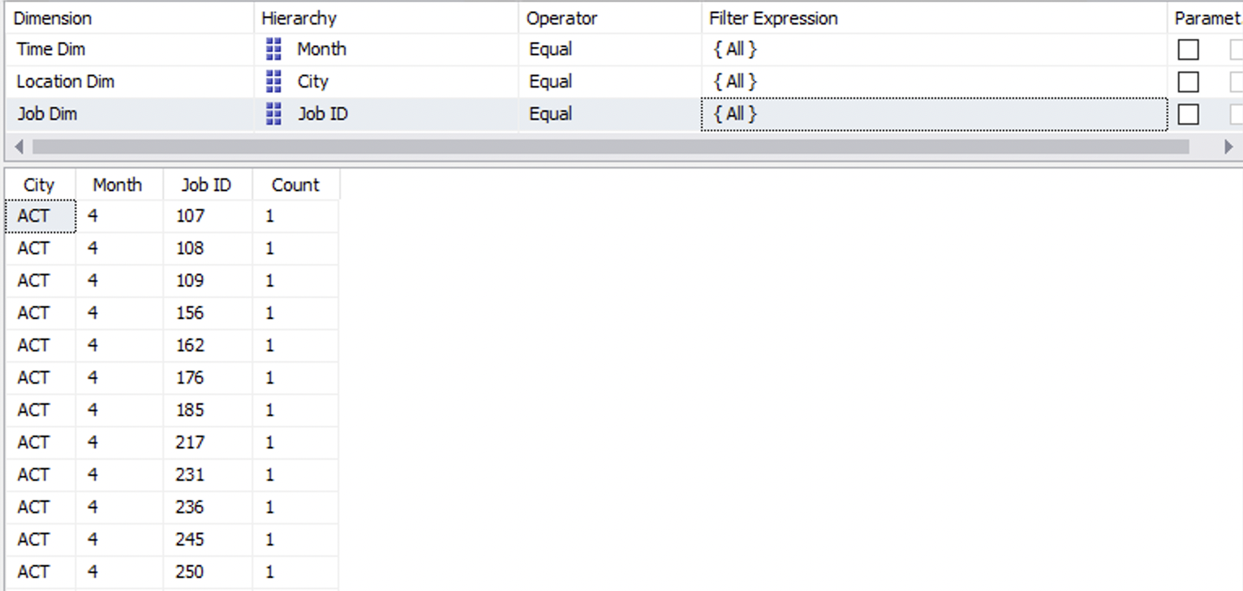

In each state, what job category is highly requested?

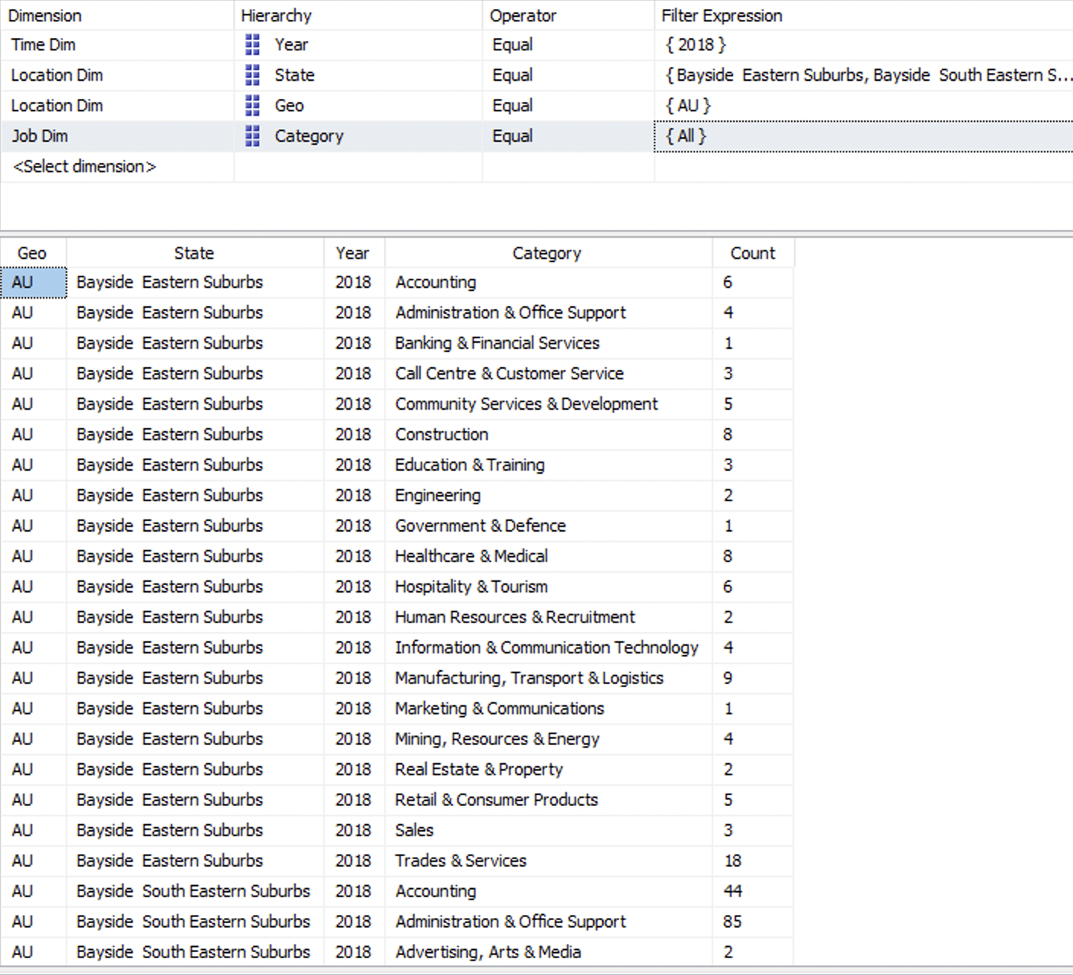

1. What is the total number of job types required in 2018 in Australia?

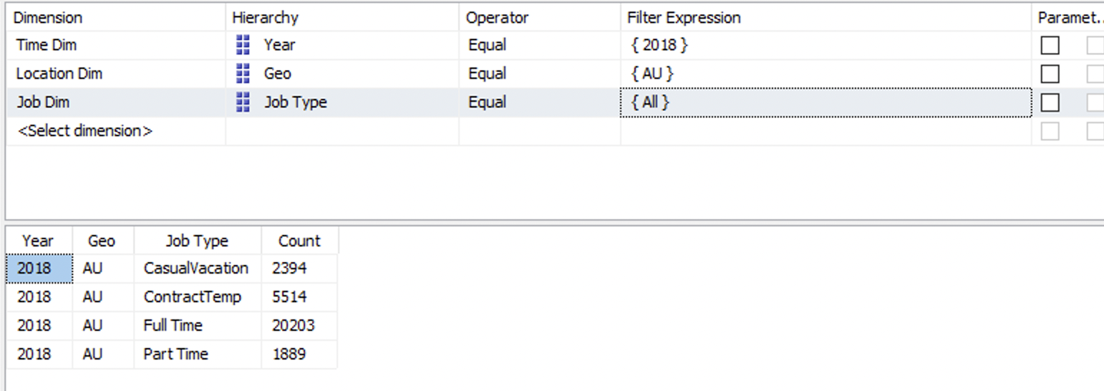

What job type is highly requested by each state?

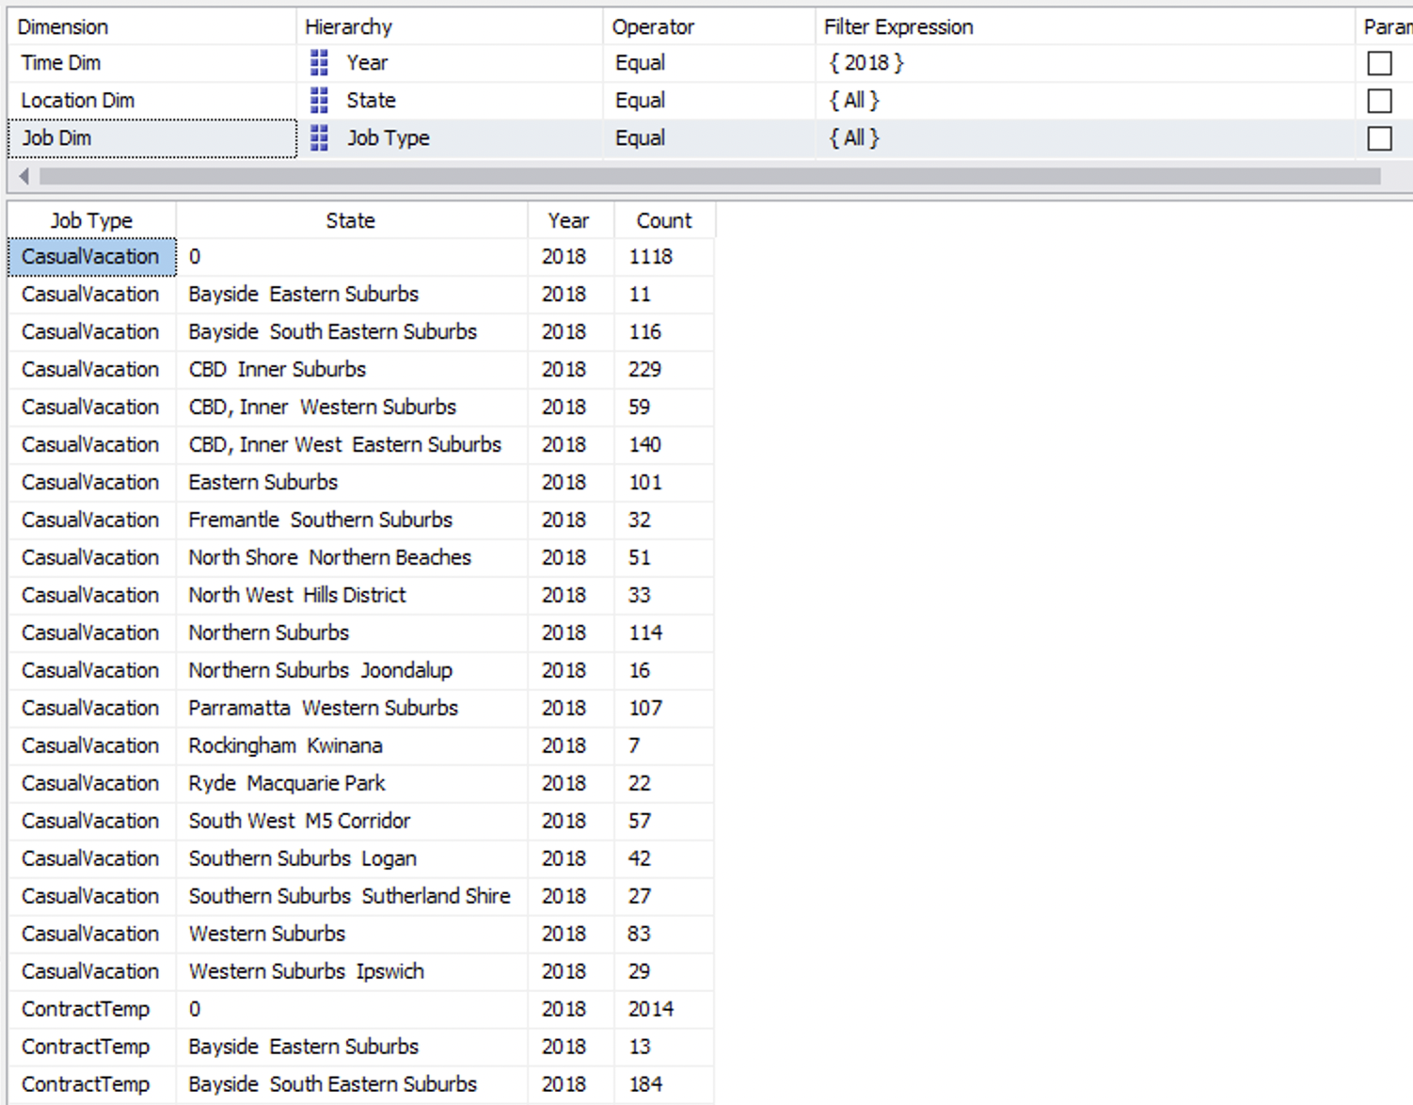

1. In a month, which state has the highest number of request for a specific job type?

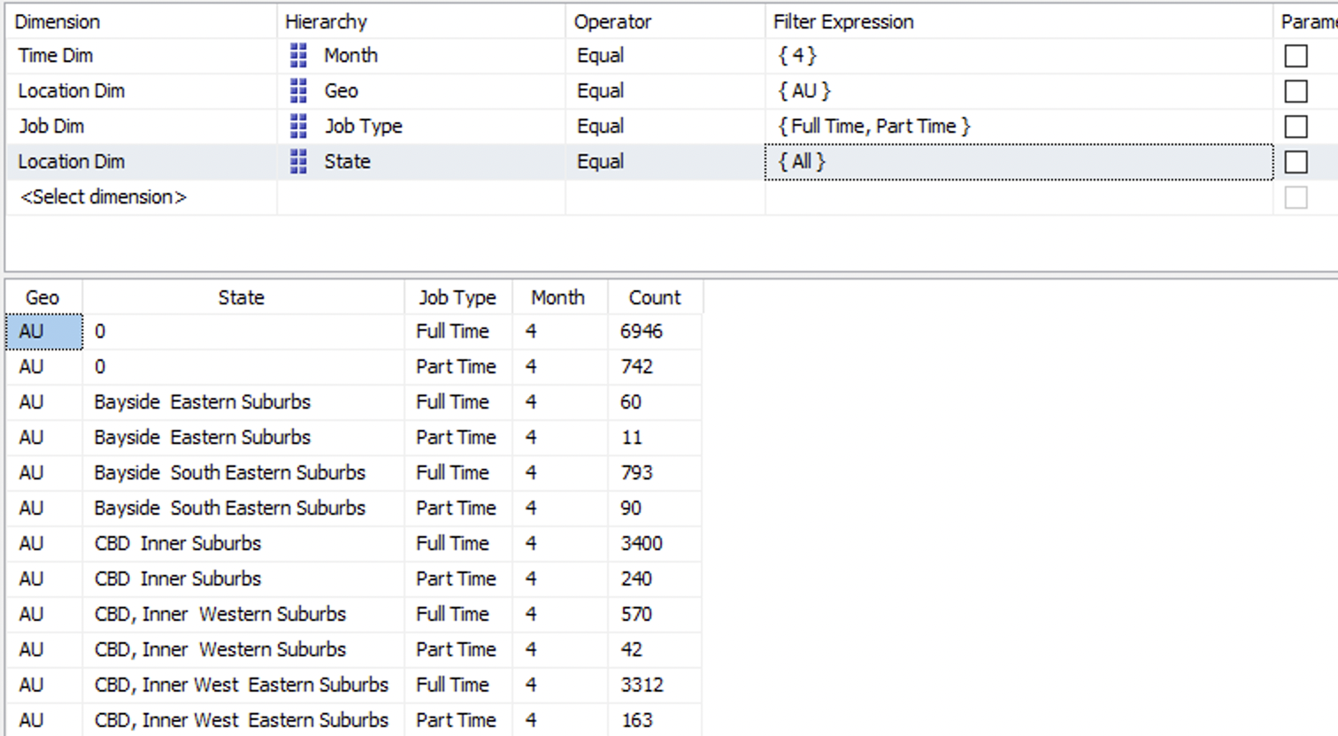

1. What job is highly requested by companies in Australia 2018?

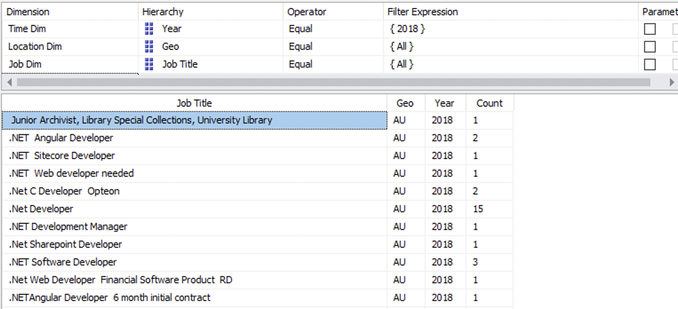

**Cube diagram:**

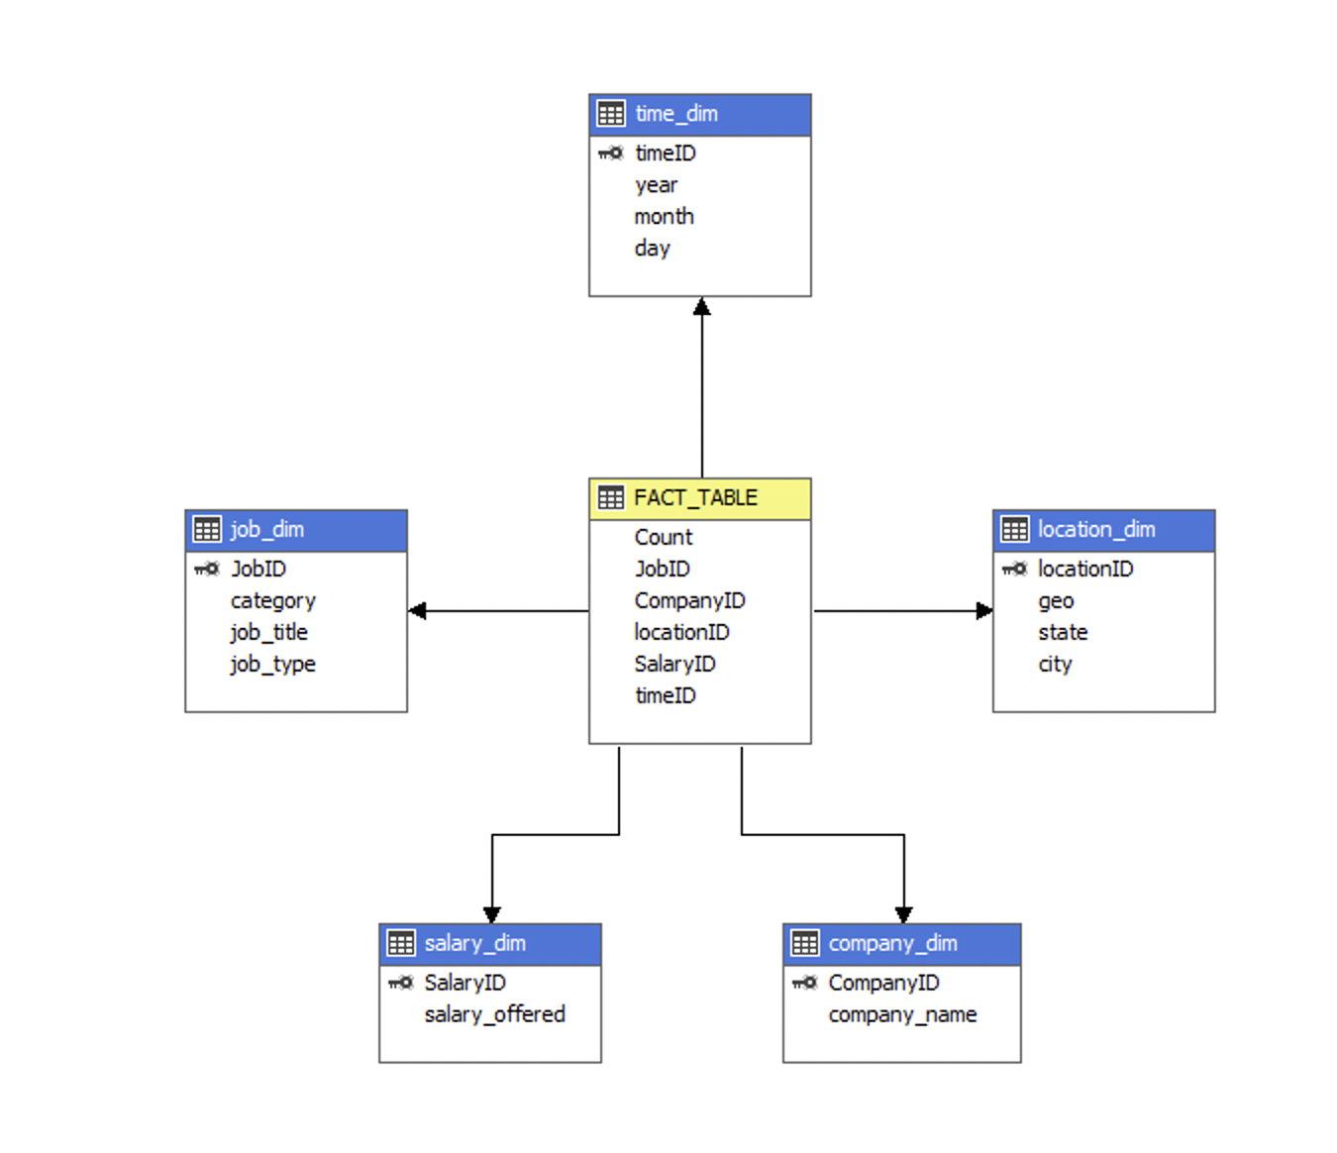

**Visualisation Results with PowerBI**

Business Queries

1. What job category is high in demand in Australia in 2018?

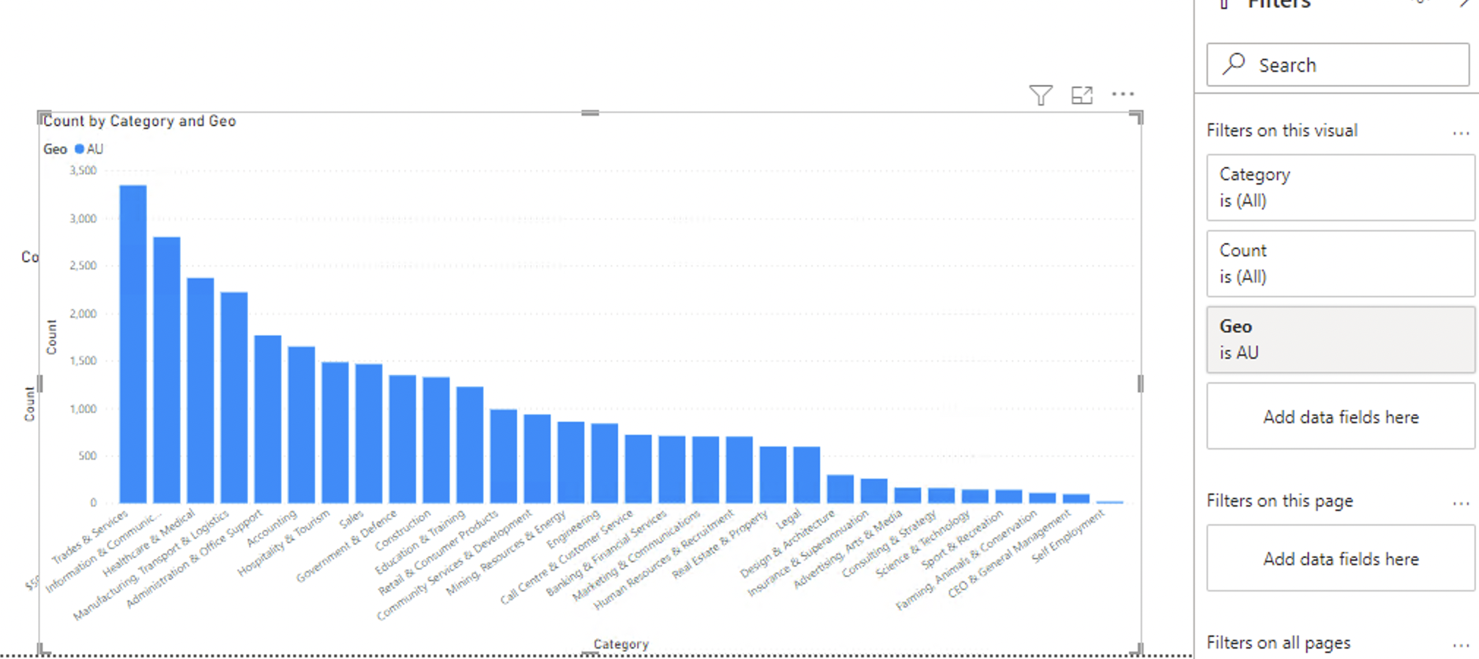

What companies are looking for a specific job category in Australia in 2018? For example Accounting

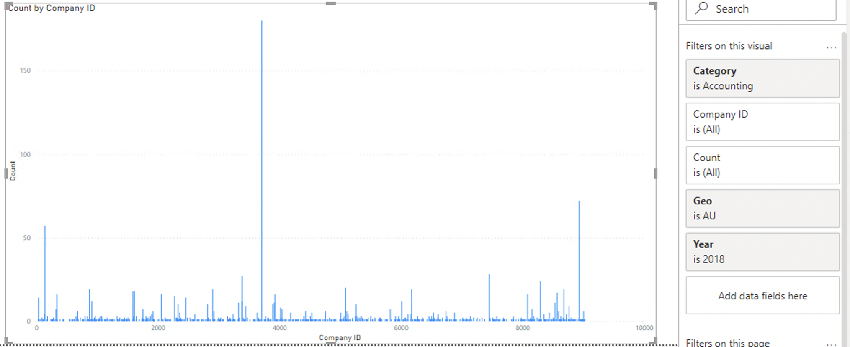

How much is the salary offered by the company for this category in 2018? For example company with ID 37.

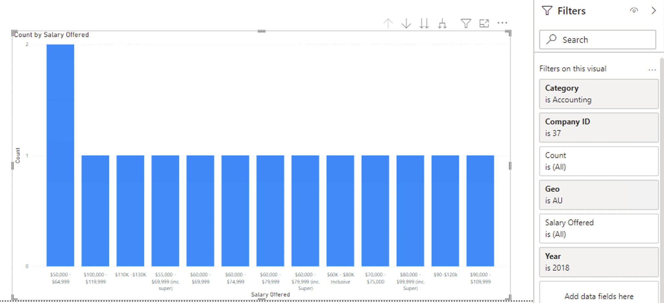

In each city, which job category is high in demand?

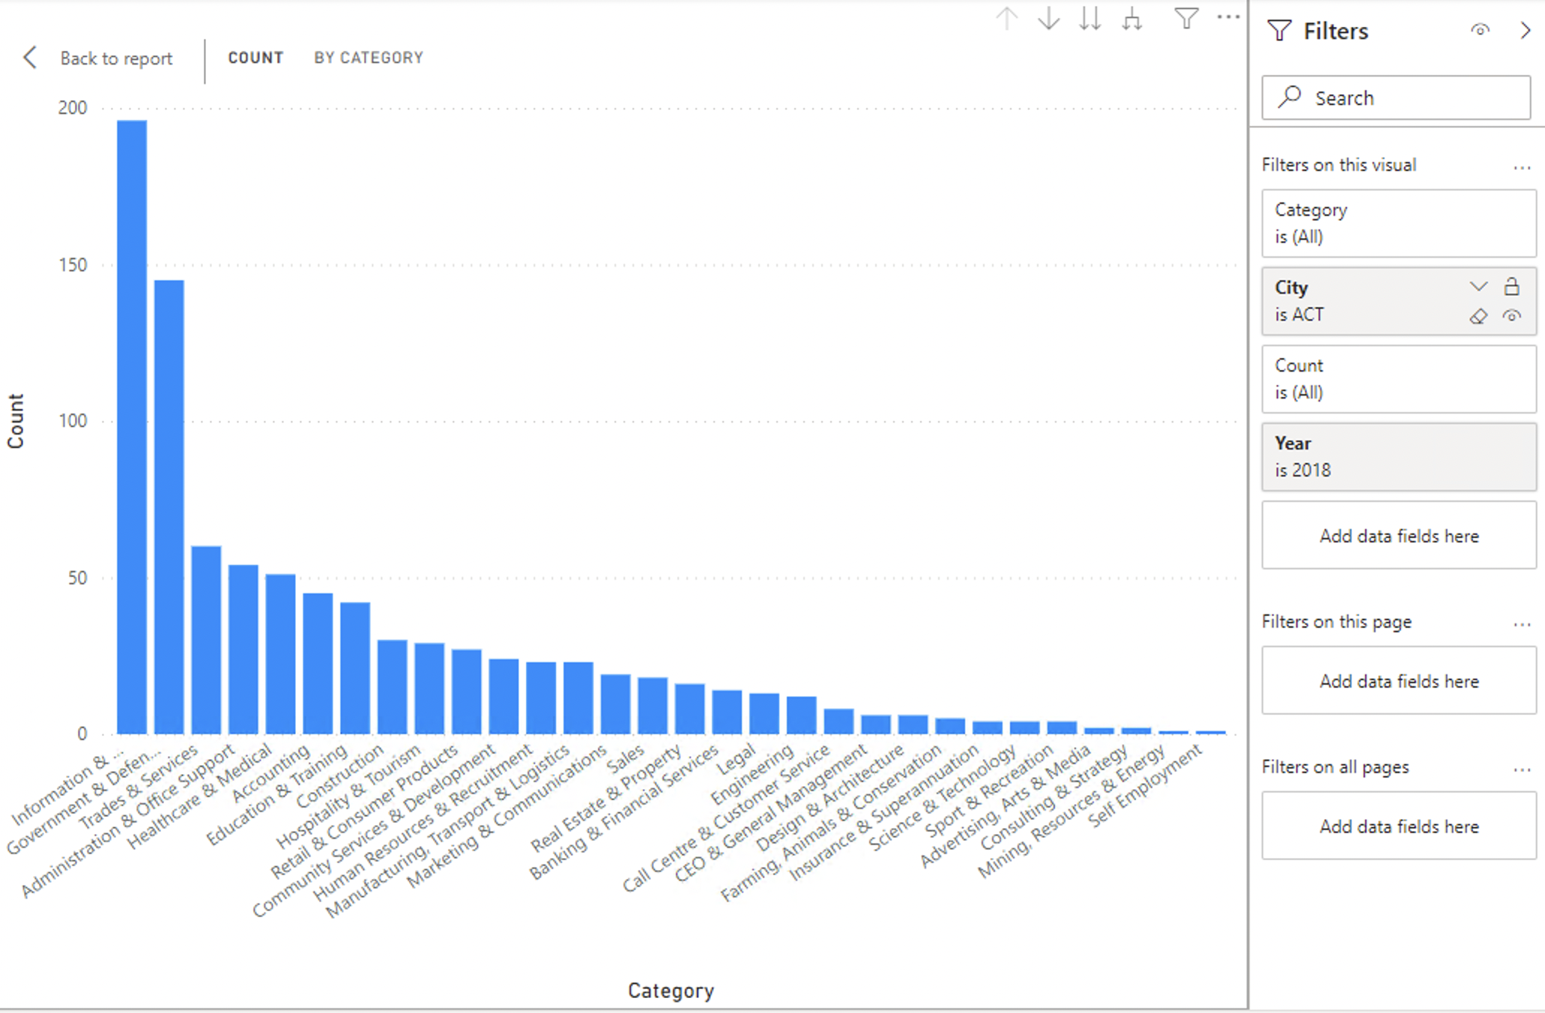

1. In a month, what is the number of job demands in each city of Australia?

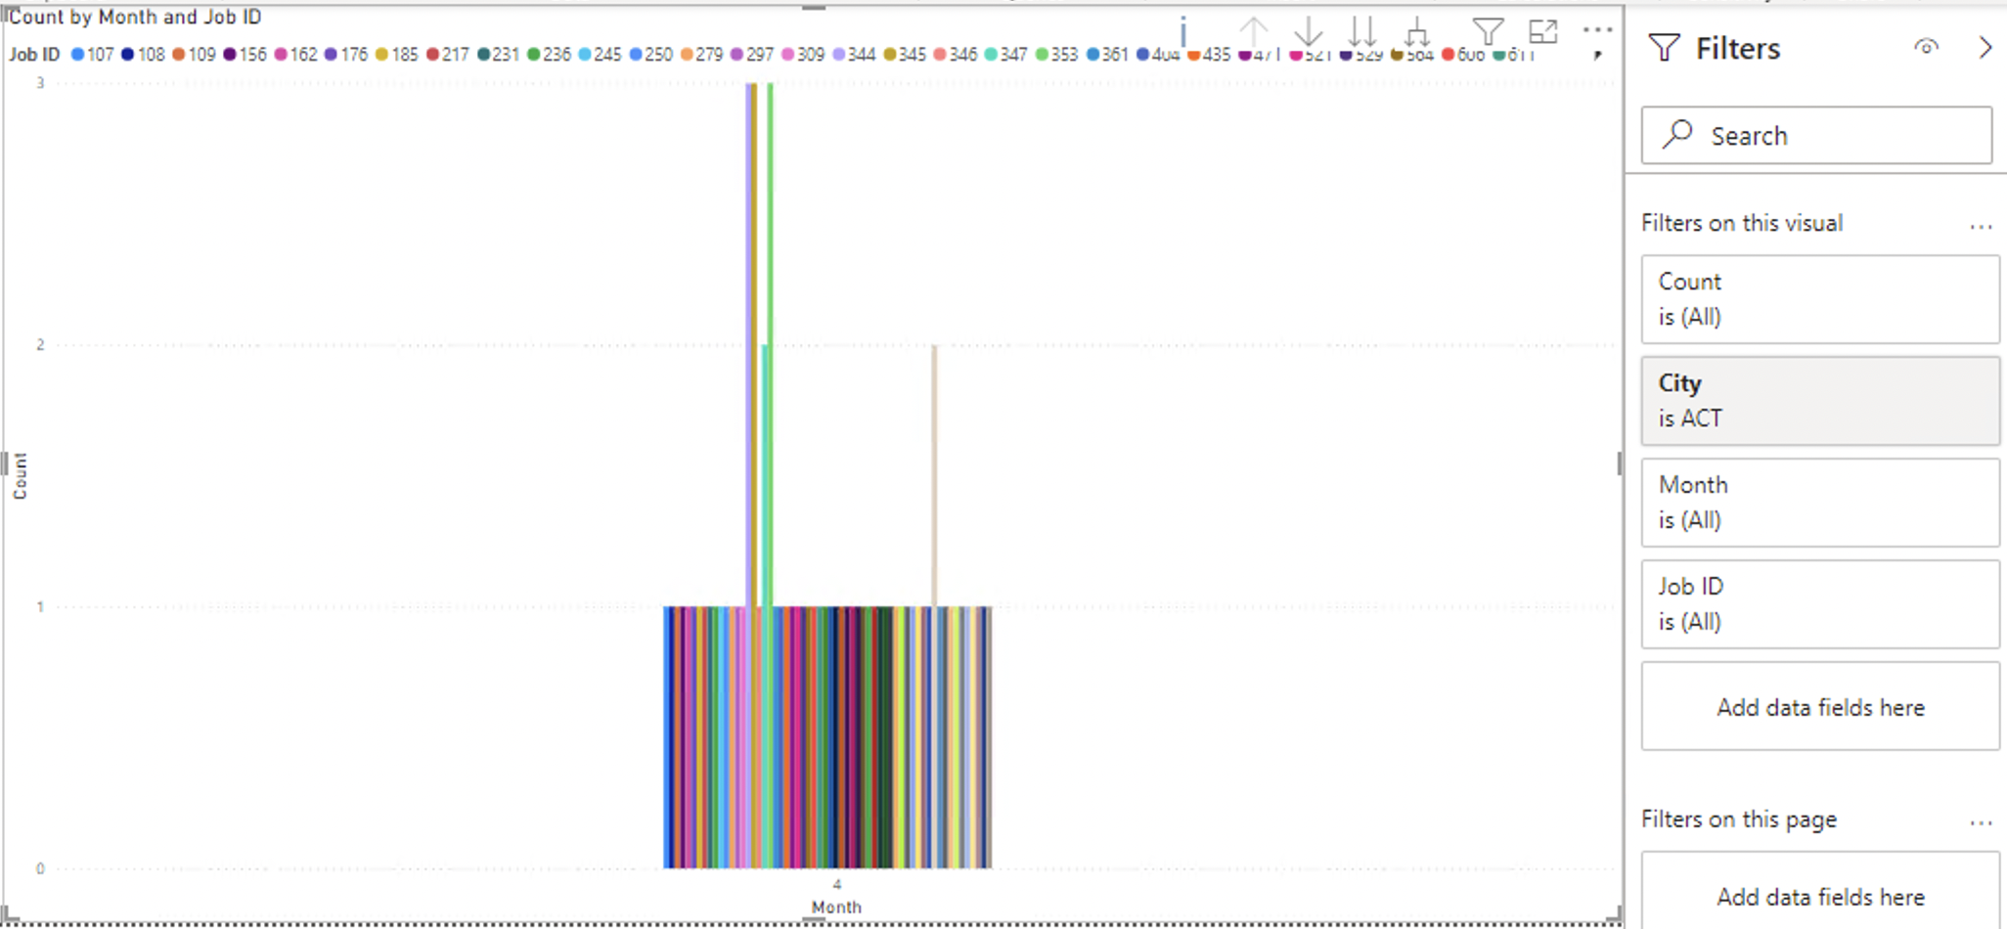

In each state, what job category is highly requested?

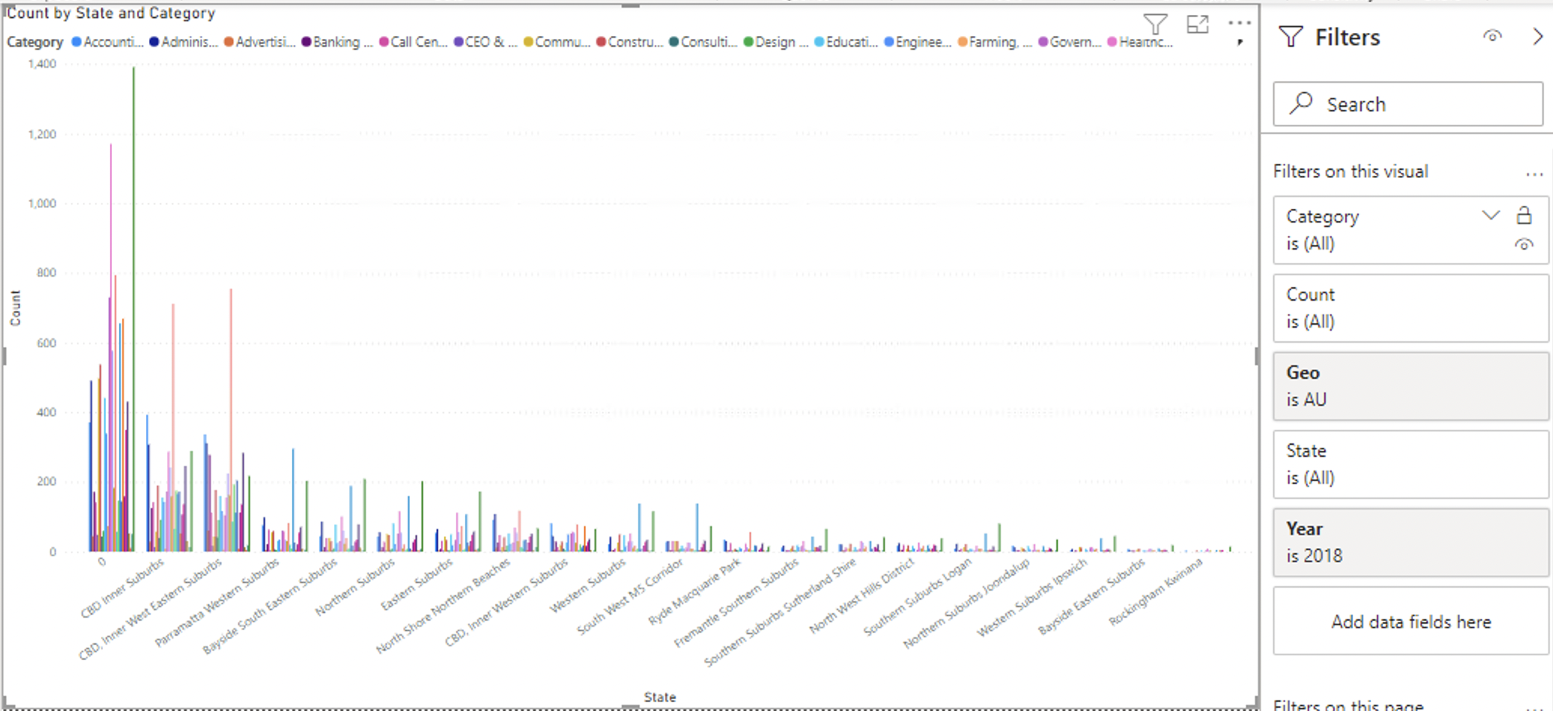

1. What is the total number of job types required in 2018 in Australia?

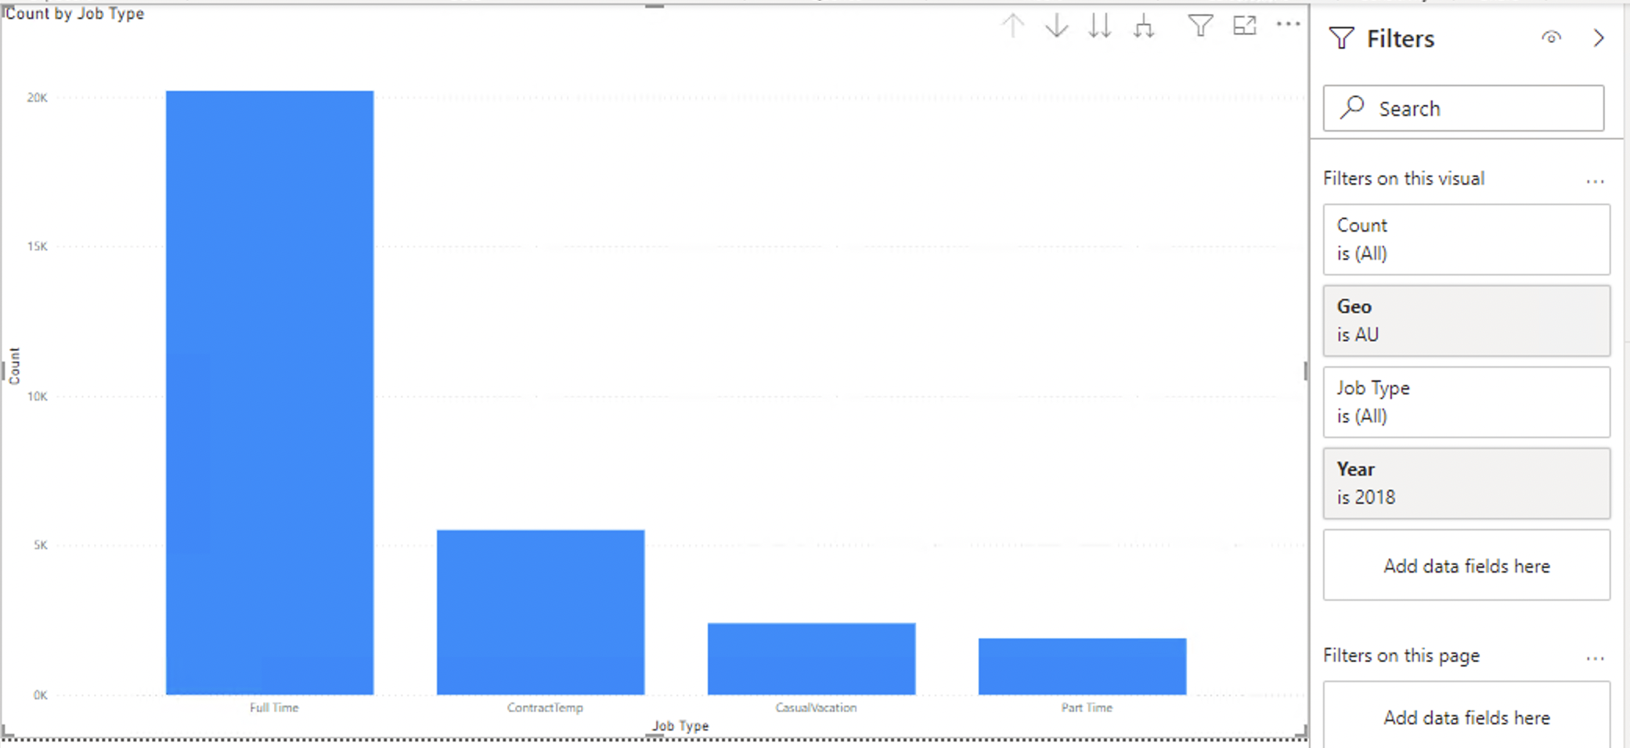

What job type is highly requested by each state?

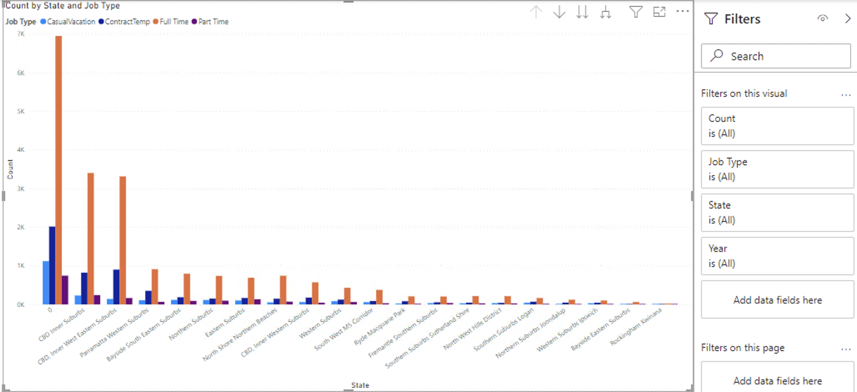

1. In a month, which state has the highest number of request for a specific job type?

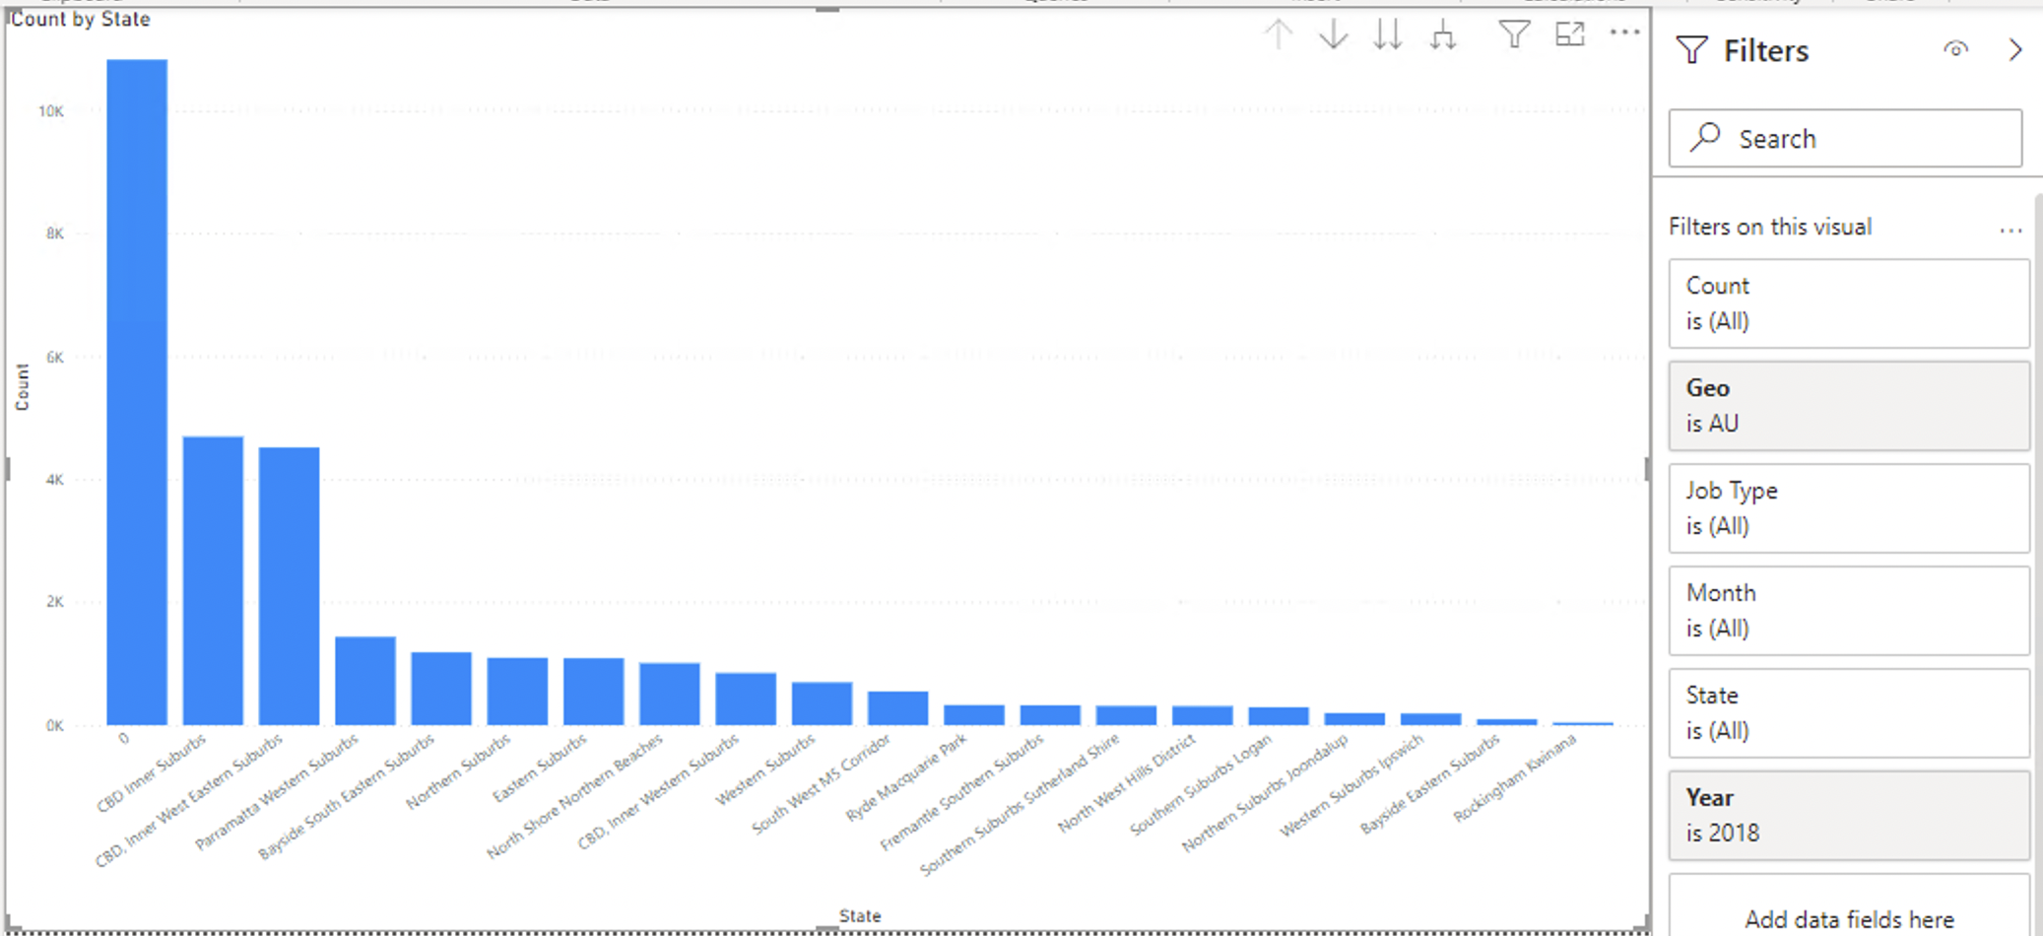

1. What job is highly requested by companies in Australia?

